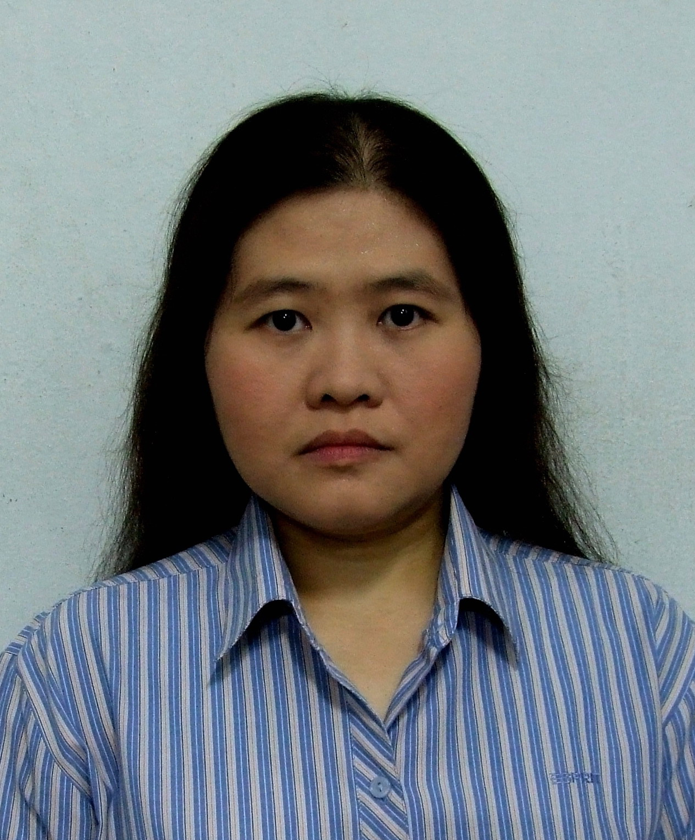
THITIKANYA CHOLCHAIPAISAL (ฐิติกัลญา ชลชัยไพศาล)
41/21 Moo.1 Chom thong Rd.,
Chom thong, Bangkok 10150
Telephone: 0-2477-2010 , 0-2476-5690
Mobile: 08-1390 2255
E-mail address : thitikanya@yahoo.com

Position Sought:
- Import & Export Manager

Current Salary:
- 44,340 THB.

Expected Salary:
- 48,000 THB.

Education:
- 1992 – 1995 : Bachelor of Business Administration,
The University of the Thai Chamber of Commerce
Major : International Business Management
Overall GPA 2.40

Additional Qualification:
- Language Proficiency : English (good)
- Computer Skills : Ms Office (Words, Excel, Power Point), Outlook Express, Internet
Explorer
- Typing Skills : English: 40 wpm. Thai: 35 wpm.

Business Trip Experience:
- Apr. 2010 : Business Trip at India for Logistics improvement purpose and FTA – Asean India (AIFTA) purpose.

THITIKANYA CHOLCHAIPAISAL (ฐิติกัลญา ชลชัยไพศาล)

Work Experience:
- Daikin Trading (Thailand) Ltd. (May 2007 – Present)
Type of Business : A trading company of air-conditioner parts and chemical products.
(Both supply to overseas for Daikin’s group in Japan, Europe, Australia, China etc. and supply to local for Daikin Industries (Thailand) Ltd. and other local company.)
- Position : Export & Import / BOI Assistant Manager
- Responsibilities :
A ) Management Administrative
  - Weekly Management Morning Meeting with President.
  - Monthly Management Meeting.
  - Salary & Bonus Evaluation.
  - Supervise staffs 10 persons.
B ) Export Tasks
- Advise and control all Export operation jobs.
- Control for an extra privilege such as Form A, Form D, Form E, JTEPA Form.
- Checking and asking for Quotation of SEA & AIR Freight charge from Sea Lines & Freight forwarder by monthly.
- Monthly sum up shipment. (Monthly Export Volume)
- Solve any problems.
C ) Import & BOI Tasks
- Advise and control all Import operations jobs.
- Advise and control claim process.
- Advise and control BOI procedures & BOI stock.
- Advise and control BIS 19 transfer number.
- Advise and control all Licenses for chemical products.
- Solve any problems.
D ) Other Tasks
- Be Lead Auditor of Team working group 2 for ISO 14001 internal audit.
- Also be Auditor and Auditee.
- Control and update Legal & Other Requirement.
- Evaluate and follow up Environment activities of each Team working groups to achieve target.
- Control all procedures of Team working group 2.
THITIKANYA CHOLCHAIPAISAL (ฐิติกัลญา ชลชัยไพศาล)

- NEC Logistics (Thailand) Co., Ltd. (Jul. 2001 – Apr. 2007)
Type of Business : Service Provider for Logistics function (Import – Export Procedure, Warehouse and Transportation Arrangement) to NEC’s group and non NEC’s group.
- Position : Import & Export Supervisor
- Responsibilities :
- Supervise and Solve any problems for Import – Export Procedure to NEC’s group (NEC Infrontia Thai Ltd. / BOI & BIS19 privilege company).
- Supervise Import Procedure for supporting their parts on time delivery.
- Supervise Export Procedure for sending their produces to any customers by smoothly.
- Supervise their BOI & BIS19 privilege.
- Supervise staffs 7 persons.
- Coordinate and follow up shipment status both Import – Export with NEC Logistics in each side country.
- Claim process arrangement (Import).
- Monthly Import – Export ’s report.
- Solve any problems

- Thai Wacoal Public Co., Ltd. (Nov.1995 – Jun.2001)
Type of Business : Produce garment products such as Ladies’ Wear product under “Wacoal” brand, Children’s Wear product under “Enfant” / “Little Wacoal” / “Kiddy Rabbit” / “Trombone” / “ELLE” / “BSC” brand and etc. both for Domestic and Export.
- Position : Export Officer and External Coordinator
- Responsibilities :
- All external contacts. (Customers and Suppliers)
- Factory-level exporting procedures.
- Present products to foreign customers.
- Coordinate with foreign customers and suppliers.
- Prepare Pro-forma Invoice, Invoice and Packing List.
- Contact Air & Sea freight forwarders or liners, also shipping agency.
- Inform the details of shipment (Shipping Advice) and the balance of payment after finished the shipment.
- Prepare documents for negotiation with the bank in case of L/C conditions.

THITIKANYA CHOLCHAIPAISAL (ฐิติกัลญา ชลชัยไพศาล)

Personal Information:
- Date of birth : August 6, 1973
- Age : 38
- Place of birth : Bangkok, Thailand
- Religion : Buddhist
- Nationality : Thai
- Citizenship : Thai
- Health : Excellent
- Marital Status : Single
- Gender : Female
- Interests : Languages
- Hobbies : Reading, Studying languages (English and Japanese) from the
news or music
- Personalities : Good communicating skills, Patient, Enthusiastic, Initiative, Calm
and Courteous

Reference:

References are available on request.

